**Week 4**

**Implementation of a Local DNS Server**

**and Authoritative Nameserver**

**Name:**

1)

2) LIKHITH R

**SRN:**

1)

2) PES1UG20CS659

**Section:** K

**Observation Notebook Requirements:**

**For ‘ping www.flipkart.com’, answer the following questions**

1. **Locate the DNS query and response messages. Are then sent over UDP or TCP?**

**Answer:**

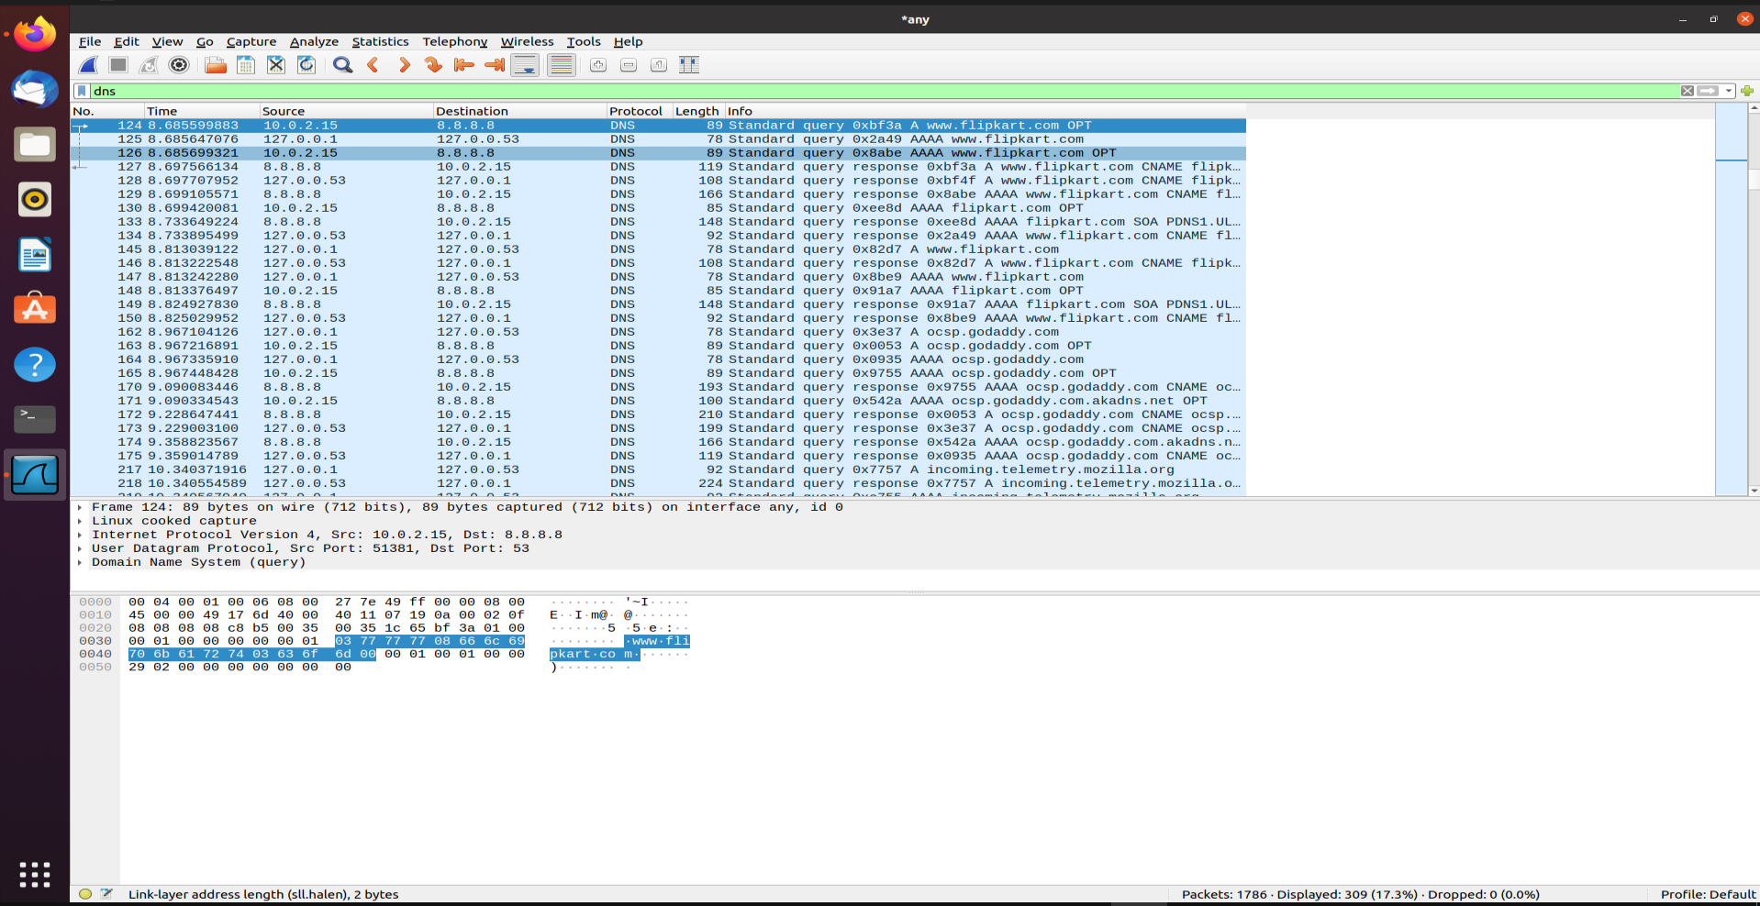

The DNS queries and their responses are all sent over UDP.

1. **What is the destination port for the DNS query message? What is the source port of DNS response message?**

**Answer:**

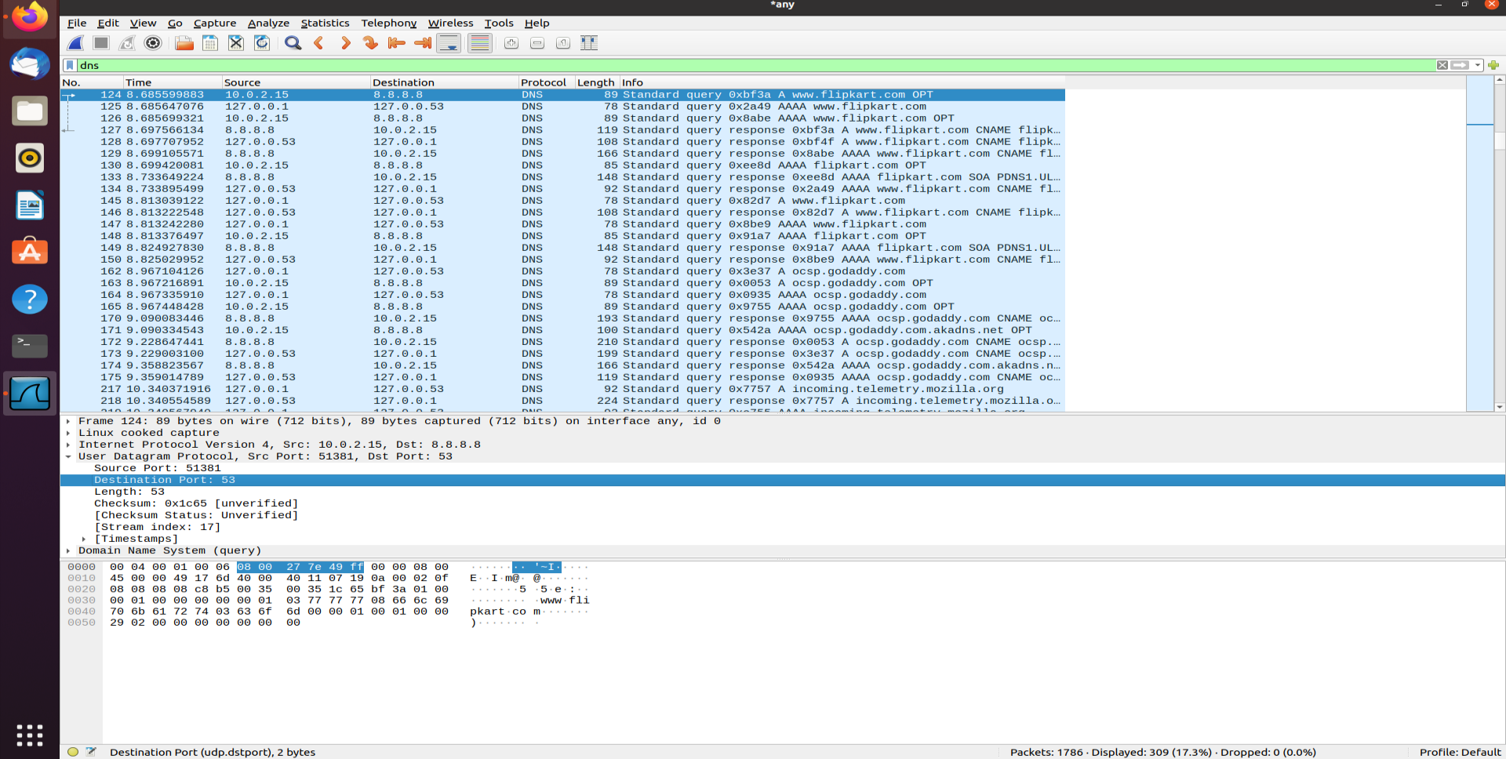

The destination port for the DNS queries and source port for the responses are both 53.

1. **To what IP address is the DNS query message sent? Use ipconfig to determine the IP address of your local DNS server. Are these two IP addresses the same?**

**Answer:**

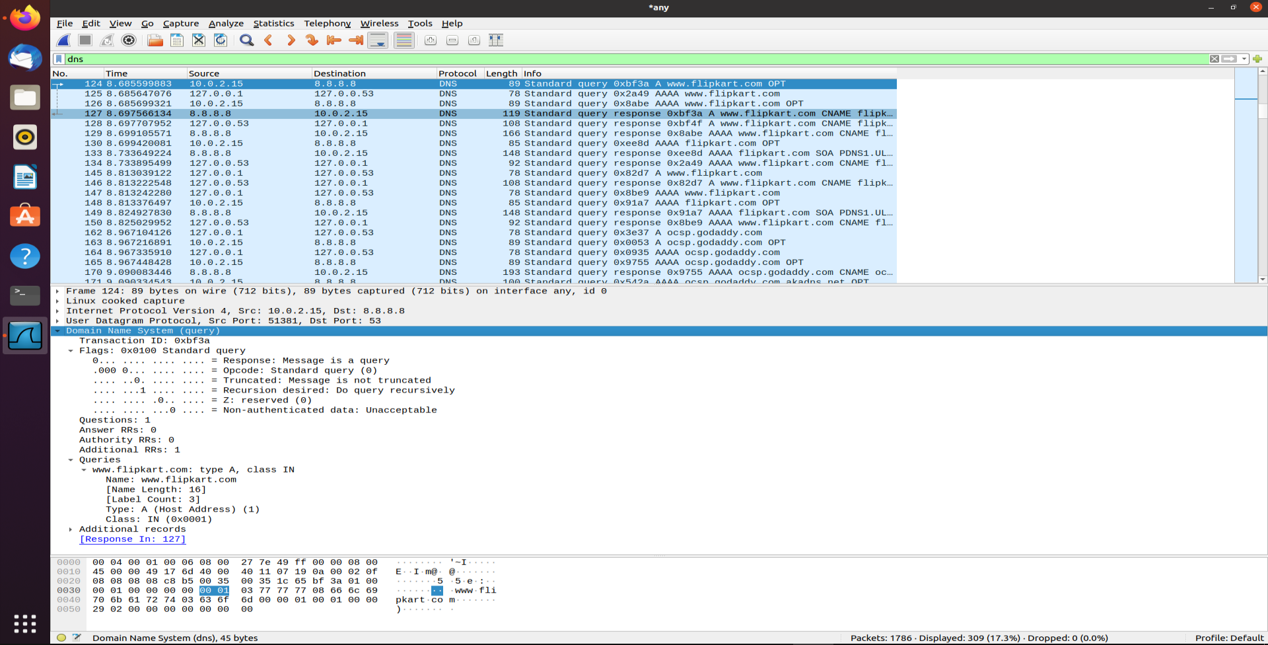

The DNS query is sent to the machine on which the DNS server is running, and if there is no result, it is sent to one of the alternative DNS servers.

**4) Examine the DNS query message. What “Type” of DNS query is it? Does the query message contain any “answers”?**

**Answer:**

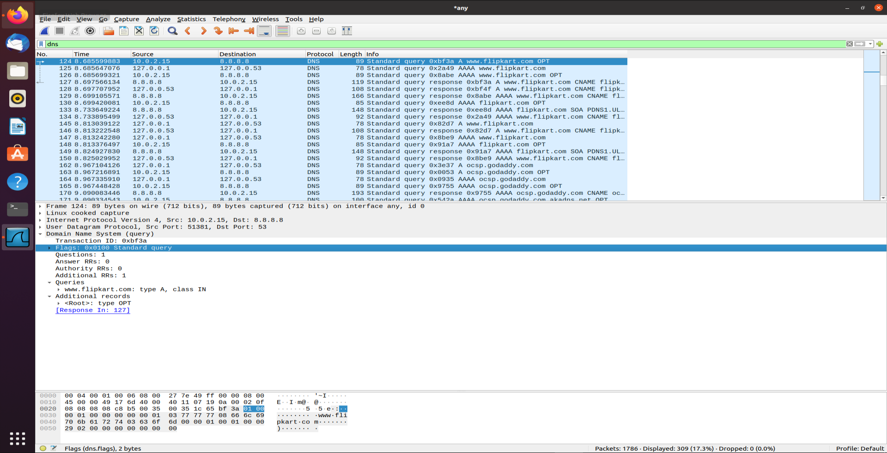

The type of query is mentioned as Standard Query. The query message contains no answers.

**5) Examine the DNS response message. How many “answers” are provided? What do each of these answers contain?**

**Answer:**

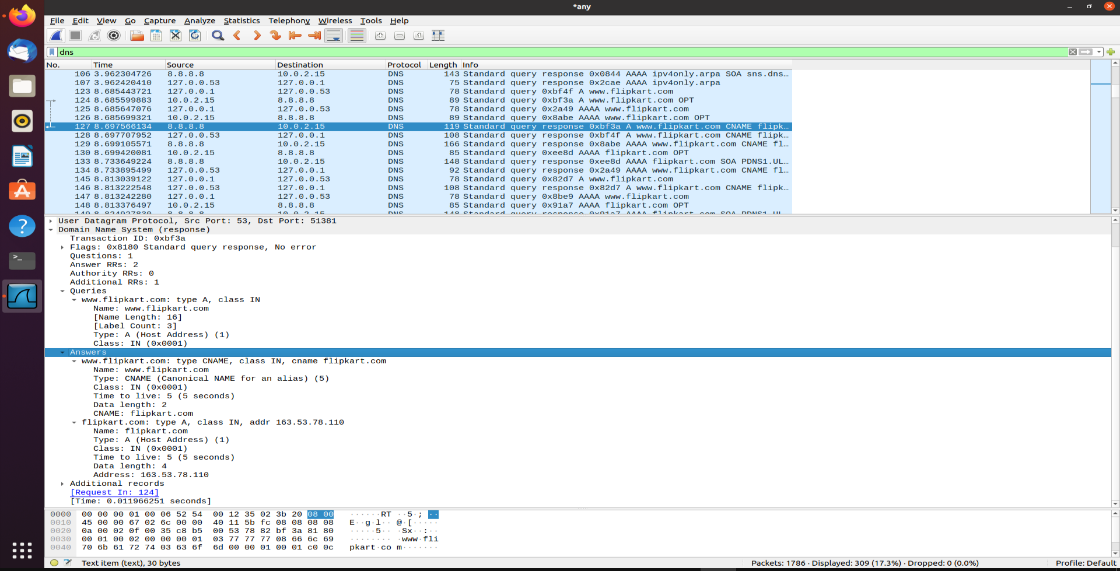

There is either one or many answers depending on the request. Each answer contains either the IP or another nameserver.

**6) Consider the subsequent TCP SYN packet sent by your host. Does the destination IP address of the SYN packet correspond to any of the IP addresses provided in the DNS response message?**

**Answer:**

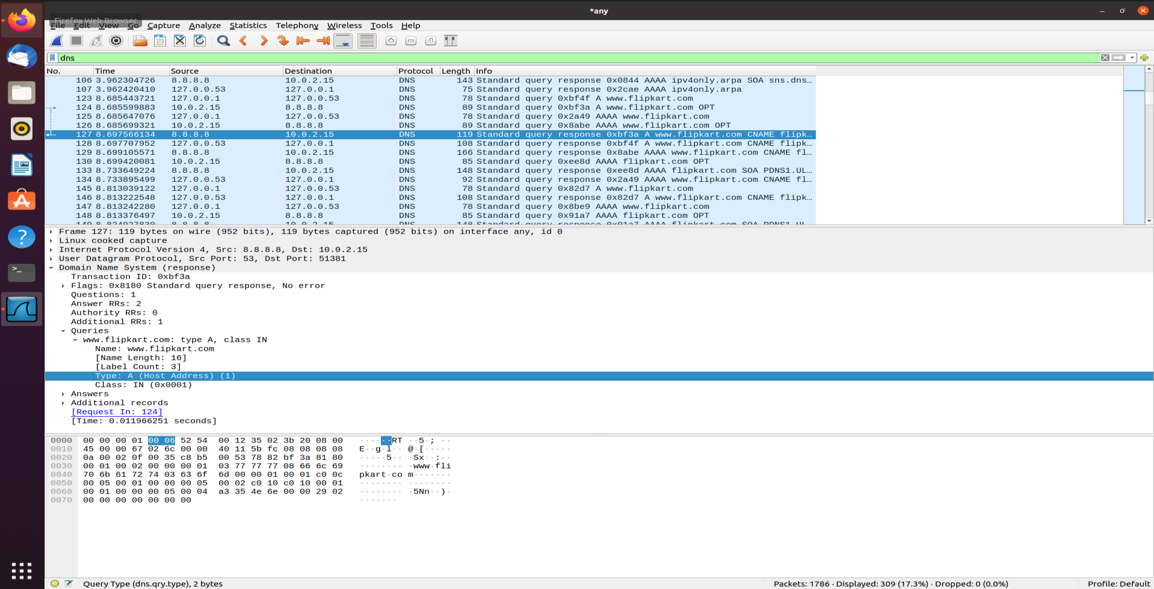

The destination IP address of the SYN packet do correspond to the IP addresses provided in the DNS reply messages.